

**REPORT MANUAL OF JOBSHEET**

**Practicum, Tasks and Questions**

**(Network programming)**

|  |  |  |  |  |
| --- | --- | --- | --- | --- |
|  | **Name** | **:** | **Brian Sayudha** |  |
|  | **Class / NIM** | **:** | **3G / 1841720158** |  |
|  | **Major** | **:** | **D-IV Informatics Enginering** |  |
|  |  |  |  |  |
|  |  |  |  |  |

Practicum 1

Code

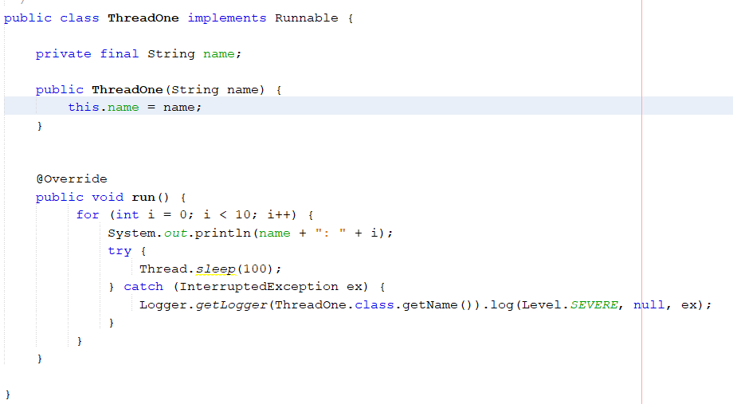

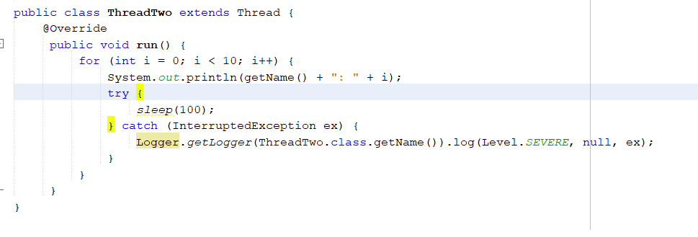

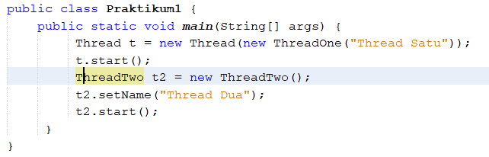

Result

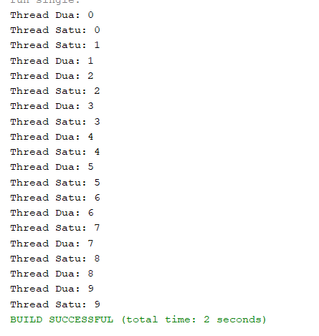

Question

1. What is the function of the sleep () method?

Answer : For interval / delay at poped up the message

2. State the advantages and disadvantages of creating a thread with the Extends class Thread and implementing the Runnable interface?

Thread

Advantages :

1. Reduce development time

2. Reduce maintenance cost

3. Improve performance

Disadvantages :

1. Multiple threads can interfere with each other when sharing hardware

2. Execution times can be degraded

Implement Runnable

Advantages :

1. we can save a space for our class to extend any othe class

2. it shares same object to multiple thread

Disadvantages :

Practicum 2

Code

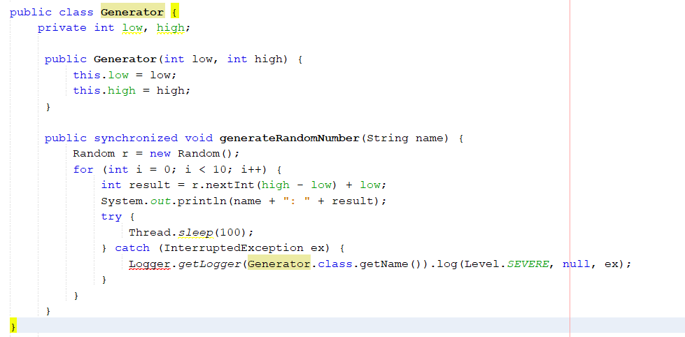

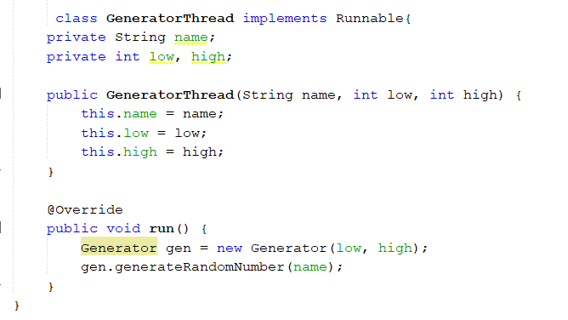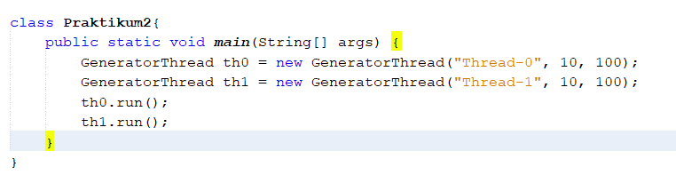

Result

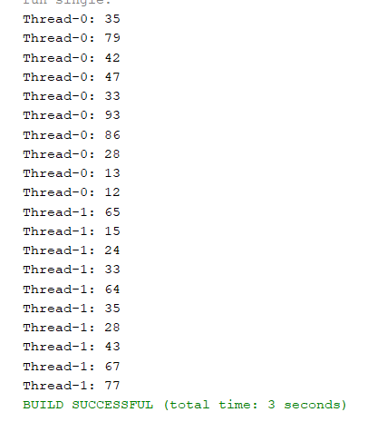

Question

1. What are Class Generators used for?

Answer : Class Generators is used to generate the random number

2. Is the keyword function synchronized in the Generator class?

Answer : used to access control process from shared resources from many threads until only one threads that can access the resources in 1 time

Assignment

Code

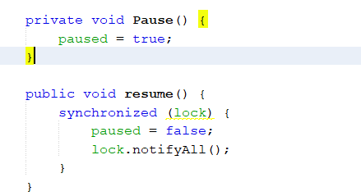

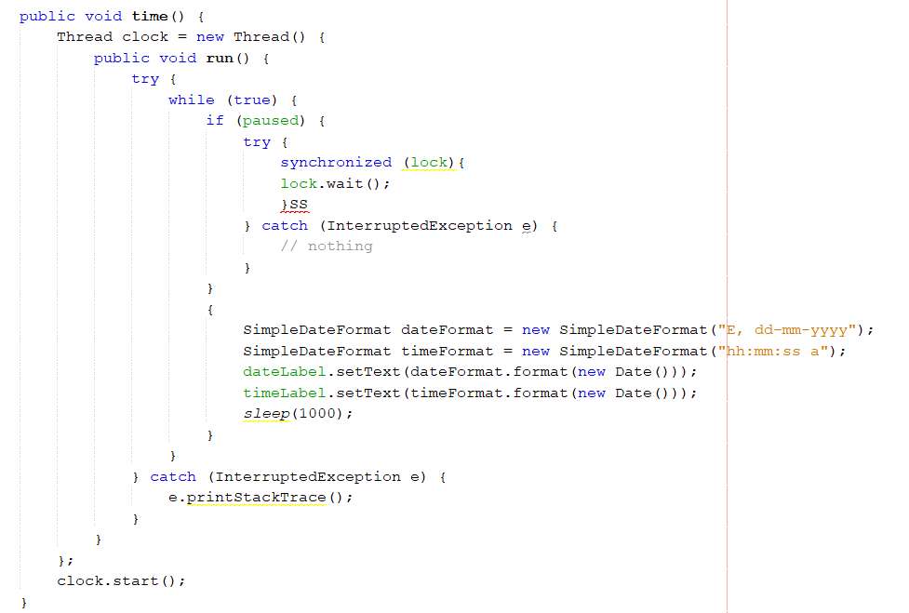

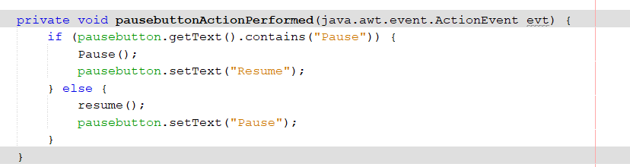

Result

